**DAILY ONLINE ACTIVITIES SUMMARY**

|  |  |  |  |  |  |  |  |
| --- | --- | --- | --- | --- | --- | --- | --- |
| **Date:** | **15/06/2020** | | | | **Name:** | **Syed Rabeya Aamir** | |
| **Sem & Sec** | **8th B** | | | | **USN:** | **4AL16CS112** | |
| Online Test Summary | | | | | | | |
| **Subject** | | **SMS** | | | | | |
| **Max. Marks** | | **60** | | **Score** | | **---** | |
| Certification Course Summary | | | | | | | |
| **Course** | **MACHINE LEARNING ALGORITHM EXPLAINED.** | | | | | | |
| **Certificate Provider** | | | **Aws** | **Duration** | | | **6 hrs** |
| Coding Challenges | | | | | | | |
| **Problem Statement:**  **1) Python Program for simple interest.** | | | | | | | |
| **Status: Solved** | | | | | | | |
| **Uploaded the report in Github** | | | | **YES** | | | |
| **If yes Repository name** | | | | **rabeya** | | | |
| **Uploaded the report in slack** | | | | **YES** | | | |

**Online Test:**

**Mail not received.**

**Certification Course Details:**

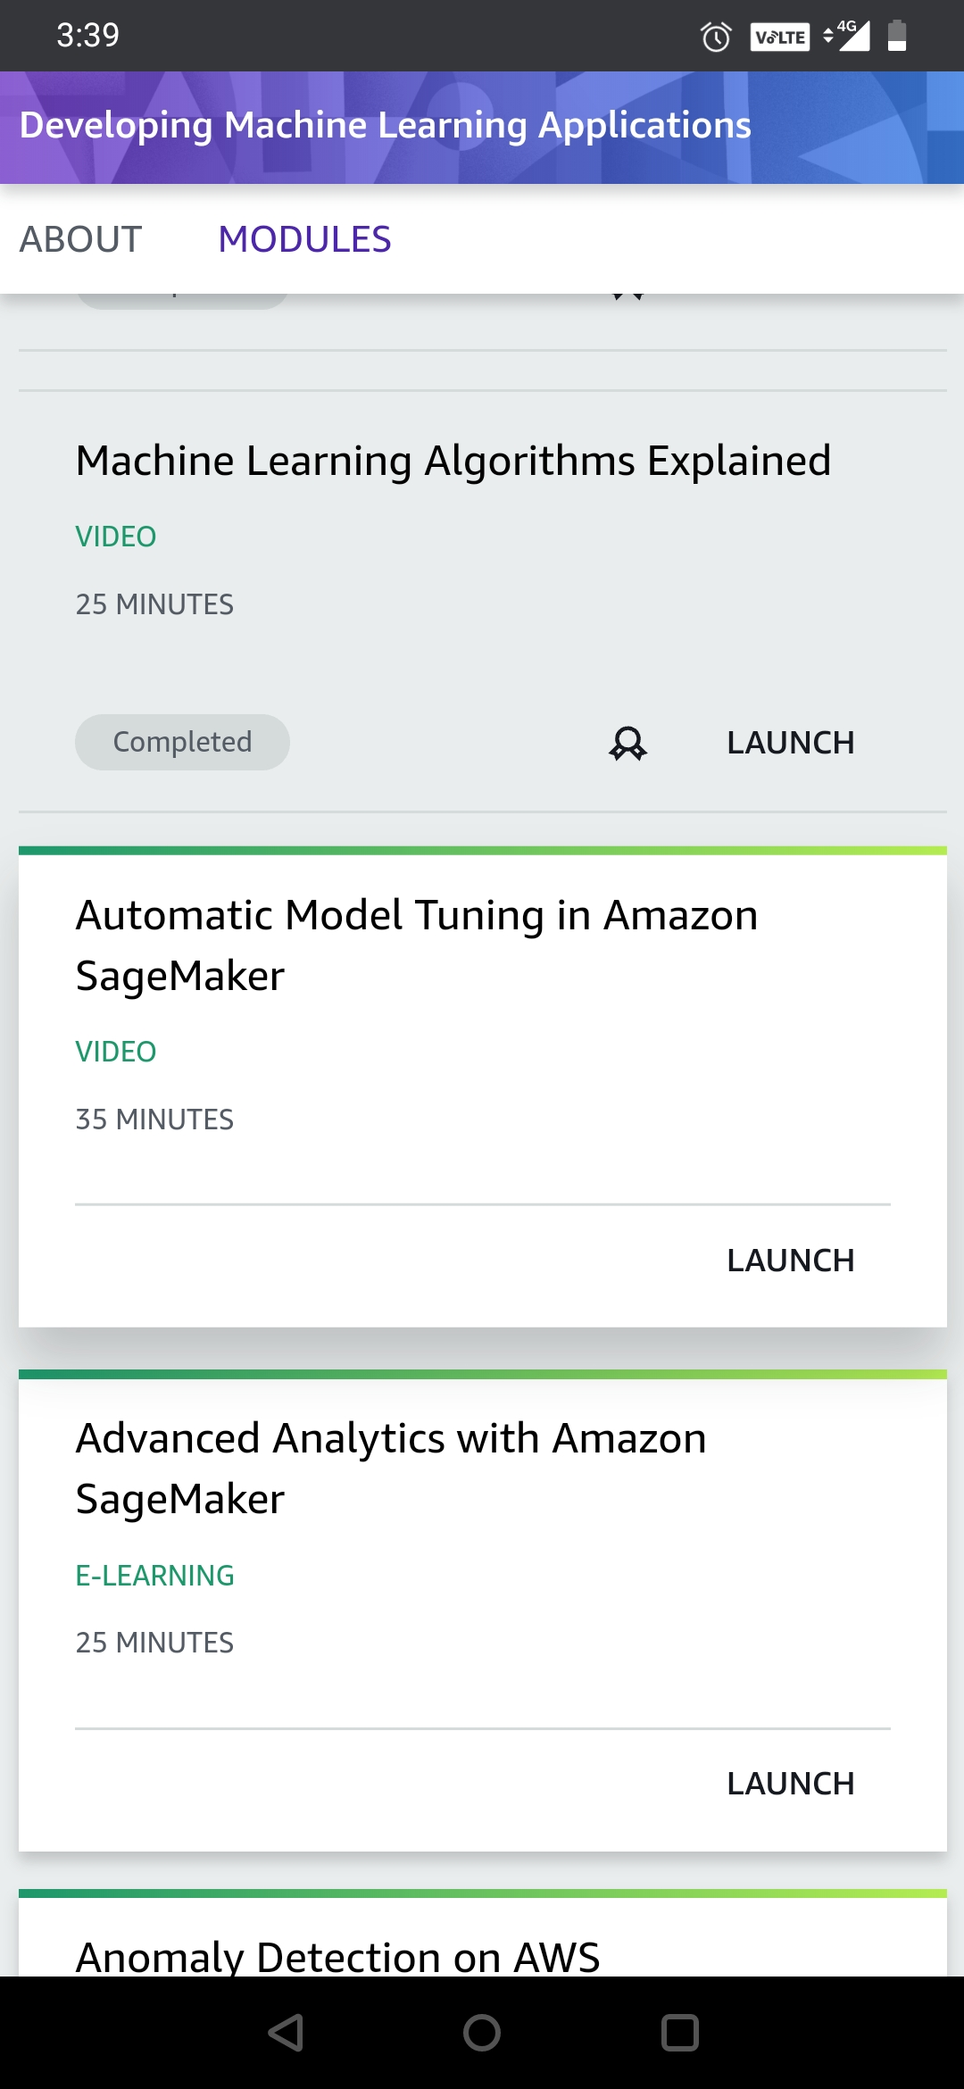

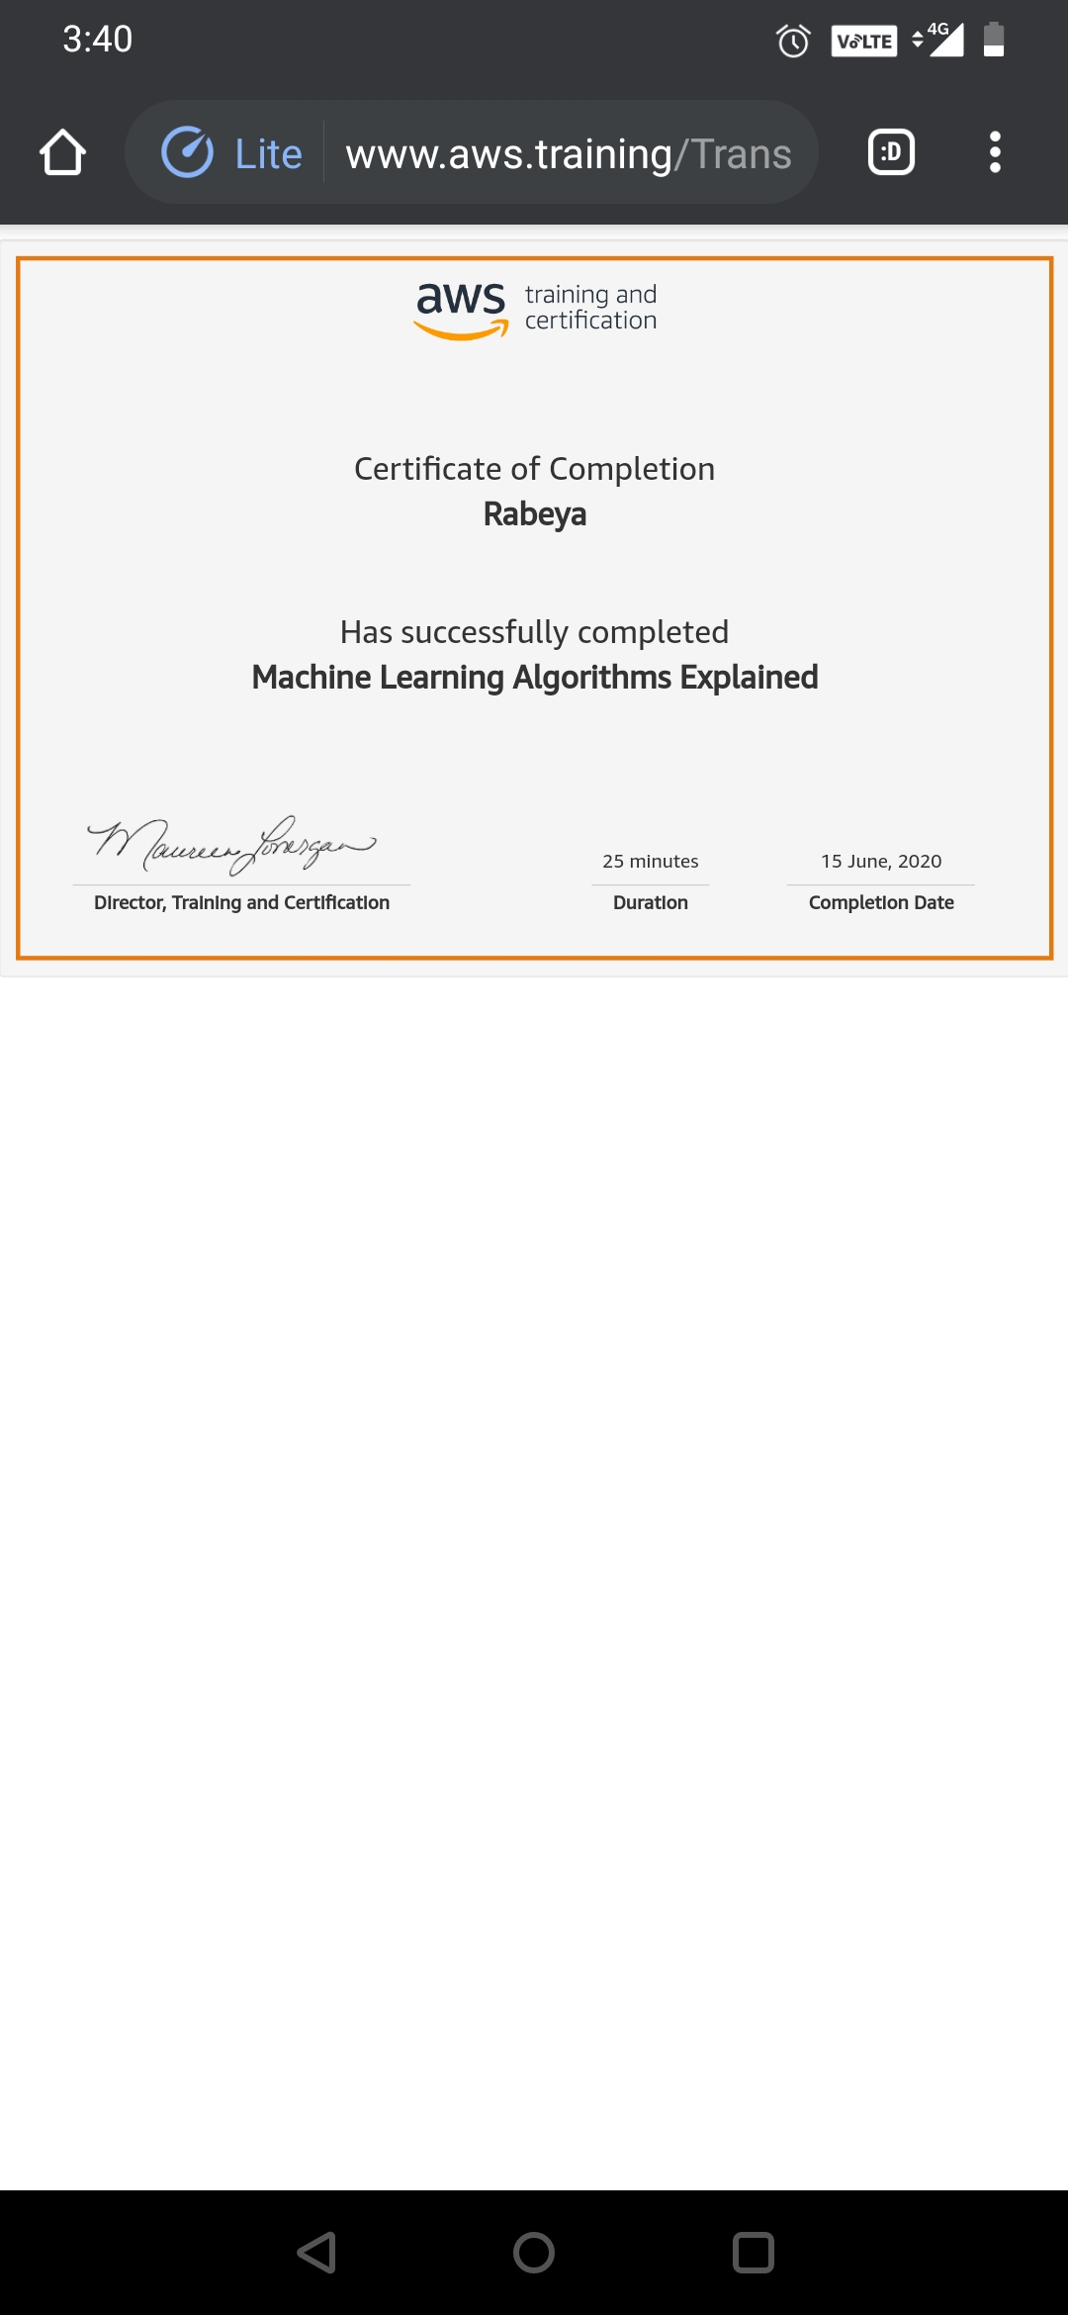

# CODE:

Program no:1

# Python Program for simple interest.

def simple_interest(p,t,r):

print('The principal is', p)

print('The time period is', t)

print('The rate of interest is',r)

si = (p * t * r)/100

print('The Simple Interest is', si)

return si

simple_interest(8, 6, 8)